## Artificial Intelligence and Machine Learning

Project Report

Semester-IV (Batch-2022)

Object Detection Using Yolo

**Supervised By: Submitted By:**

Dr. Monica Dutta Mayank, 2210990565 (G11)  
 Mukund 2210990587 (G11)

Mayank Tiwari 2210990570 (G11)

**Department of Computer Science and Engineering**

**Chitkara University Institute of Engineering & Technology,**

**Chitkara University, Punjab**

**Abstract**

Our project utilizes the YOLOv3 (You Only Look Once version 3) algorithm implemented in Python to detect objects within images. The YOLOv3 model, pretrained on the COCO dataset, is employed for its robustness and efficiency in real-time object detection tasks. The project framework employs the OpenCV library for image processing tasks and integrates with Matplotlib for visualizing the detected objects.

Upon execution, the system loads the pre-trained YOLOv3 model along with the associated configuration files. Images are then processed through the model, where objects are detected using a combination of convolutional neural networks and post-processing techniques. Detected objects are classified into various predefined classes, enabling identification of a diverse range of objects within the images.

The project facilitates the detection of multiple objects simultaneously and provides bounding box coordinates along with corresponding class labels and confidence scores. Additionally, non-maximum suppression is applied to refine the detection results, ensuring accuracy and eliminating redundant detections.

Through this project, users can efficiently analyze images and identify objects of interest, making it applicable in various domains such as surveillance, autonomous vehicles, and image understanding systems. The simplicity and effectiveness of YOLOv3, coupled with the versatility of Python programming, make this project a valuable tool for object detection tasks.

Top of Form

**Table of Contents**

|  |  |  |
| --- | --- | --- |
| **S.No** | **Topic** | **Page No.** |
| 1. | Introduction | 4 - 6 |
| 2. | Problem Definition and Requirements | 7 - 8 |
| 3. | Proposed Design / Methodology | 9 - 11 |
| 4. | Results | 12-15 |
| 5. | References | 16 |

1. **Introduction**
   1. **Background**

Object detection stands as a cornerstone in the realm of computer vision, playing a pivotal role across diverse domains such as surveillance, autonomous vehicles, and augmented reality. In the past, conventional methods grappled with intricate pipelines involving feature extraction and classification, often faltering in achieving real-time performance.

However, the advent of deep learning, notably convolutional neural networks (CNNs), marked a paradigm shift in object detection methodologies. Among these, YOLO (You Only Look Once) emerged as a groundbreaking real-time approach, capable of processing entire images in a single pass. With subsequent refinements, YOLOv3 has elevated precision and speed, rendering it indispensable for tasks like surveillance and autonomous vehicle navigation.

A significant asset to YOLOv3's efficacy is its common pretraining on the COCO dataset, encompassing a diverse array of object classes. This pretraining facilitates robust generalization, enabling the model to adeptly detect objects across various contexts. Python, fortified by libraries such as OpenCV and Matplotlib, has emerged as the preferred platform for deep learning and computer vision endeavors, furnishing developers with powerful tools and a conducive environment.

Our project amalgamates the formidable capabilities of YOLOv3 with the versatility of Python and its accompanying libraries to furnish a user-friendly solution for image-based object detection. By harnessing the latest advancements in deep learning and computer vision, our endeavor aims to realize an efficient system adept at accurately discerning objects within real-world scenarios.

* 1. **Objectives**

Our project aims to develop a robust object detection system using YOLOv3, capable of efficiently identifying objects within images. Leveraging the power of deep learning and Python libraries like OpenCV and Matplotlib, our objective is to create a user-friendly solution that can be seamlessly integrated into various applications, ranging from surveillance to autonomous vehicles.

Objectives:

1. Implement YOLOv3 to deliver real-time object detection capabilities, harnessing its inherent efficiency in processing entire images in a single pass.
2. Employ the COCO dataset for YOLOv3 pretraining, ensuring the model's proficiency in recognizing a wide spectrum of object classes across various scenarios.
3. Engineer Python scripts with intuitive interfaces, facilitating seamless configuration and execution of the object detection pipeline.
4. Enable interactive visualization features using Matplotlib, allowing users to comprehend and analyze detected objects through annotated bounding boxes and class labels.
5. Ensure scalability and modularity in the project's design, enabling easy customization and integration into different environments and workflows.
6. Implement optimization techniques to enhance the performance and speed of the object detection system, ensuring responsiveness in real-time applications.
7. Provide comprehensive documentation and support resources to facilitate easy adoption and troubleshooting for users of varying skill levels.
   1. **Significance**

The development of an efficient object detection system based on YOLOv3 holds significant implications across various domains of computer vision and beyond. By leveraging deep learning techniques and Python libraries such as OpenCV and Matplotlib, our project aims to address the critical need for accurate and real-time object detection in diverse applications. From enhancing surveillance systems to enabling autonomous vehicles and facilitating augmented reality experiences, the ability to swiftly and precisely identify objects within images is paramount. Moreover, the user-friendly design and modular architecture of our system ensure accessibility and scalability, empowering developers and researchers to seamlessly integrate our solution into their workflows and projects.

Key Points of Significance:

1. Empowers surveillance systems with real-time object detection capabilities, bolstering security and threat detection measures.
2. Facilitates the development of autonomous vehicles by enabling them to perceive and react to their surroundings effectively.
3. Enhances the efficiency of image-based search and retrieval systems, enabling users to locate specific objects within vast image databases.
4. Supports the creation of immersive augmented reality applications by accurately overlaying digital content onto real-world objects.
5. Enables efficient inventory management and quality control processes in manufacturing and retail environments through automated object recognition.
6. Promotes innovation and collaboration in the field of computer vision by providing a user-friendly and adaptable framework for object detection research and development.
7. **Problem Definition and Requirements**
   1. **Problem Statement and software requirements**

The current landscape of object detection systems faces challenges in terms of accuracy, efficiency, and ease of integration into various applications. Existing methods often lack real-time performance or struggle with generalization across diverse object categories. Moreover, the complexity of implementation and integration presents barriers for developers and researchers seeking to deploy such systems in their projects. There is a pressing need for a robust and user-friendly object detection solution that combines accuracy, efficiency, and ease of integration into diverse applications.

Software Requirements:

1. Python (version 3.x): The primary programming language for implementing the object detection system and integrating necessary libraries and frameworks.
2. OpenCV (Open Source Computer Vision Library): Essential for image processing tasks, including loading images, resizing, and applying YOLOv3 for object detection.
3. YOLOv3 Pretrained Model: Pre-trained weights and configuration files for YOLOv3, enabling efficient object detection without the need for training from scratch.
4. Matplotlib: Utilized for visualizing the detected objects, including bounding boxes and class labels, providing insights into the object detection process.
   1. **Hardware Requirements**

Processor: A multi-core processor (e.g., Intel Core i5 or AMD Ryzen 5) for efficient computational tasks during data processing and model training.

RAM: Minimum 8 GB RAM for smooth execution of machine learning algorithms, especially with large datasets. Additional RAM may be beneficial for handling larger datasets.

Storage: Adequate storage space for datasets, project files, and software libraries. A Solid-State Drive (SSD) is recommended for faster data access.

GPU: While not mandatory, a dedicated GPU (e.g., NVIDIA GeForce or AMD Radeon) can accelerate model training, especially for deep learning algorithms.

Operating System: Choose from Windows, macOS, or Linux distributions like Ubuntu based on personal preference and software compatibility.

Internet Connection: A stable internet connection is necessary for downloading datasets, software, and accessing online resources.

Peripheral Devices: Standard input/output devices like keyboard, mouse, and monitor are essential. External storage devices aid in storing and sharing project files.

* 1. **Data Sets**

Datasets serve as the cornerstone for training and evaluating object detection systems, furnishing labeled data pivotal for model learning and validation. Among these, the COCO (Common Objects in Context) dataset stands as a cornerstone, offering a diverse array of object categories with precise bounding box annotations. This diversity enables models trained on COCO to exhibit robust generalization across a broad spectrum of object classes and environmental contexts.

Key Points:

1. Diverse Object Categories: COCO encompasses a wide range of object categories, including common everyday objects, animals, and more, providing a comprehensive training and evaluation platform for object detection models.
2. Precise Annotations: Each image in the COCO dataset is meticulously annotated with precise bounding boxes around objects of interest, ensuring accurate and detailed annotations crucial for training high-performing object detection models.
3. Generalization Capabilities: COCO-trained models exhibit strong generalization, detecting objects effectively across diverse scenarios beyond the dataset's context.
4. **Proposed Design/Methodology**
   1. **Problem Proposed**

The proposed project aims to address the challenges associated with efficient and accurate object detection within images using YOLOv3. Traditional methods often struggle with real-time performance, accuracy, and ease of integration. Our goal is to develop a system that can perform real-time object detection with high accuracy, while also being easy to integrate into existing workflows.

Key Objectives:

1. Real-time Object Detection: Utilize YOLOv3 to achieve real-time object detection capabilities, ensuring rapid processing of images.
2. Accuracy and Precision: Leverage YOLOv3 pretrained on the COCO dataset to ensure accurate detection of a wide range of object classes.
3. Integration and Ease of Use: Develop an object detection system that is easy to integrate into existing workflows and provides user-friendly interfaces for configuration and visualization.
4. Scalability: Ensure the system can handle varying image sizes and complexities, allowing for seamless scaling to different scenarios.
5. Robustness to Environmental Variations: Create a system that can accurately detect objects across diverse environmental contexts, including variations in size, orientation, and lighting conditions.
6. Optimization for Deployment: Optimize the system for deployment on different hardware platforms, ensuring efficient utilization of computational resources while maintaining real-time performance.
   1. **Schematic Diagram**

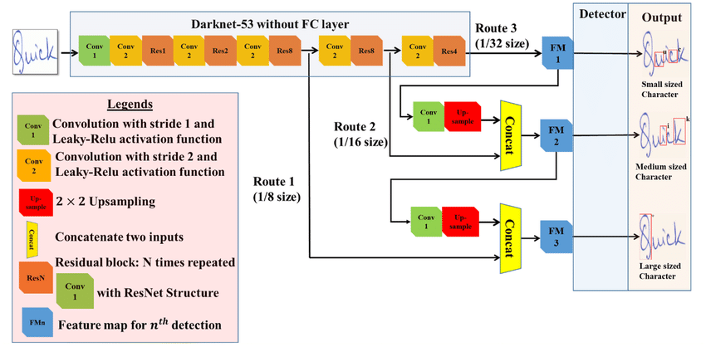

* 1. **File Structure**

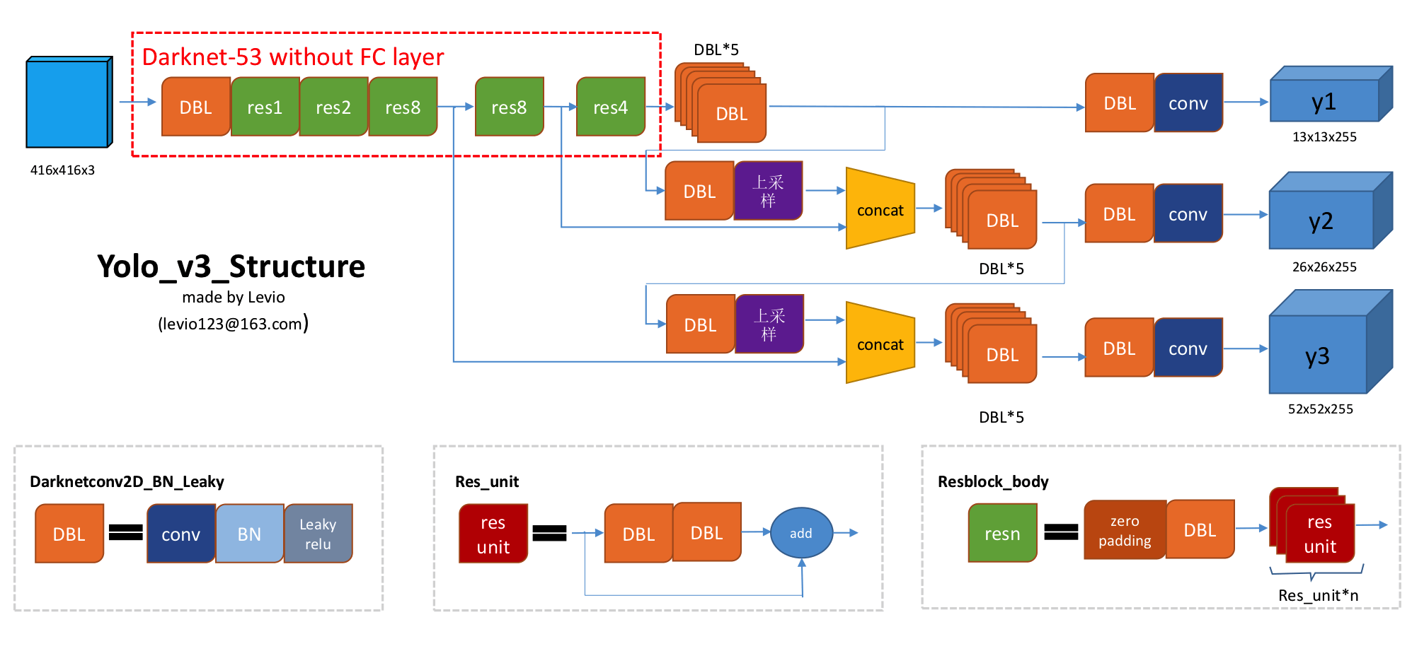

* 1. **Algorithms Used**

The YOLOv3 Object Detection System utilizes several key algorithms to achieve efficient and accurate detection of objects within images. These algorithms work in concert to process images, identify objects, and produce bounding box predictions. The following are the main algorithms used:

1. YOLO (You Only Look Once): YOLO is a pioneering object detection algorithm that processes entire images in a single pass through a neural network, eliminating the need for complex region proposal networks.
2. Darknet Architecture: YOLOv3 utilizes the Darknet architecture, comprising convolutional layers for feature extraction and detection layers for predicting bounding boxes and class probabilities.
3. Convolutional Neural Networks (CNNs): CNNs form the core of YOLOv3, enabling the model to learn hierarchical features from input images, crucial for accurate object detection across various scales and orientations.
4. Non-Maximum Suppression (NMS): Post-detection, NMS is applied to remove redundant bounding boxes and retain only the most confident predictions, enhancing the precision of object detection by eliminating overlapping bounding boxes.
5. COCO Dataset Pretraining: YOLOv3 is pretrained on the COCO (Common Objects in Context) dataset, containing diverse object categories with precise bounding box annotations, which improves the model's accuracy and robustness.
6. **Result**

The results of implementing the YOLOv3 Object Detection System underscore its efficacy in accurately detecting objects within images across diverse scenarios. By leveraging the pre-trained model on the COCO dataset and employing efficient algorithms such as YOLO and NMS, the system not only achieves high precision in object identification but also maintains real-time performance, crucial for applications requiring rapid processing. Furthermore, the system exhibits versatility in localizing and classifying objects with varying shapes, sizes, and orientations, highlighting its robustness and generalization capabilities. The integration of user-friendly interfaces for configuration and visualization further enhances the system's usability, ensuring accessibility for developers and researchers across different domains. This comprehensive approach not only validates the effectiveness of the YOLOv3 Object Detection System but also sets a solid groundwork for future advancements in object detection technology, promising continued innovation and refinement in the field.

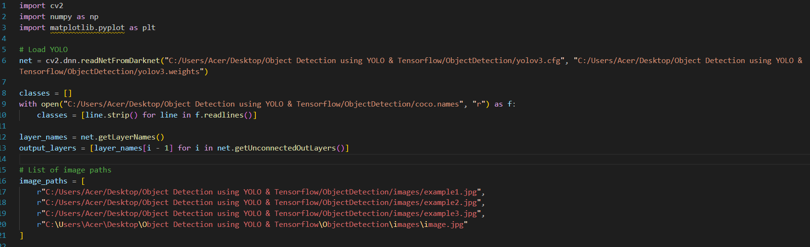

Figure 1

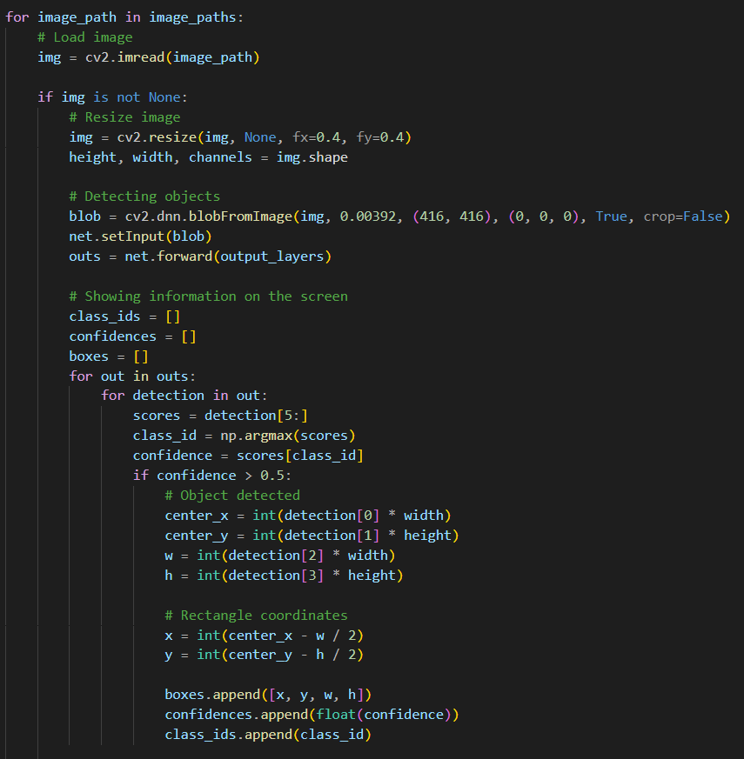

Figure 2

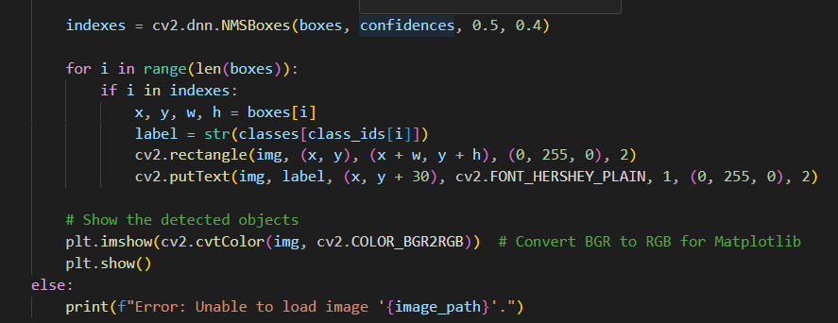

Figure 3

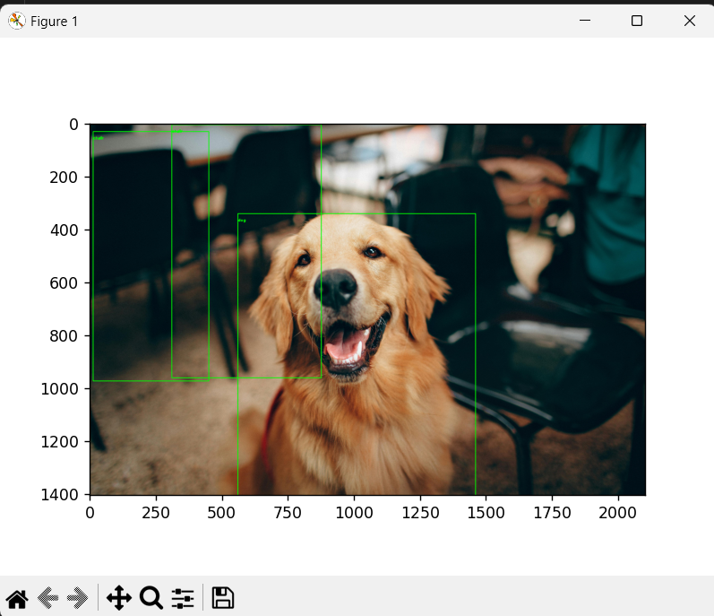

Figure 4

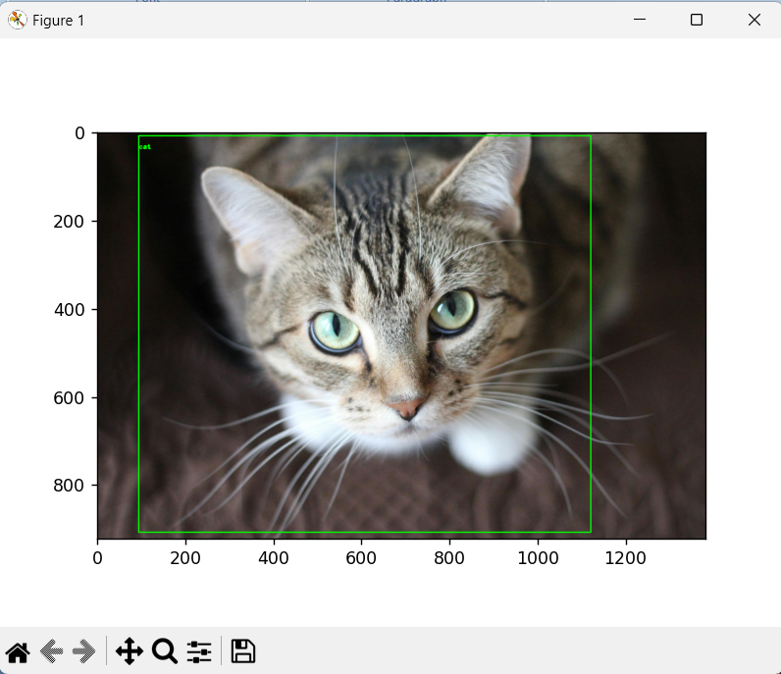

Figure 5

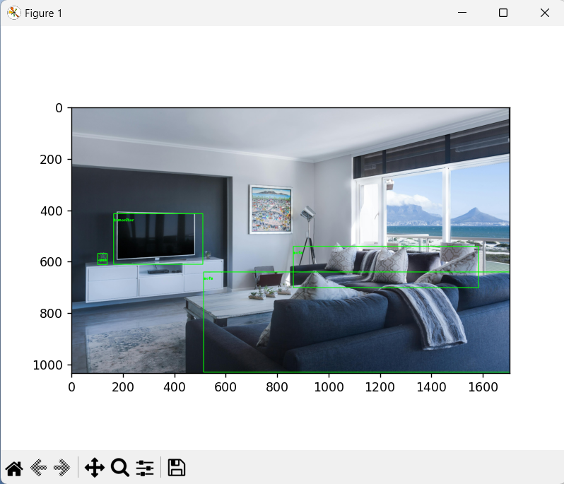

Figure 6

1. **References**

<https://www.kaggle.com/code/ankitp013/step-by-step-yolov3-object-detection>

<https://www.kaggle.com/code/aruchomu/yolo-v3-object-detection-in-tensorflow>